Ref. No: Date: 07.08.2023

Notice Regarding Orientation programme
It is hereby notify to all 2nd& 4th semester Hons, 1st Semester students (Chemistry major) that an orientation programme will be held on 18/8/2023. The programme will be start sharply at 11:00 am. The presence of all students (especially 1st semester chemistry major) must be mandatory for that day. Place: 205 (department of chemistry). All 1st semester students (Chemistry major) must submit one set of photocopy of all documents as verified on 4/8/2023.

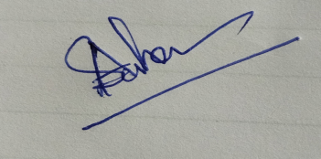
HOD
Department of Chemistry

